**Assignment 03 – WordPress CMS Website (Basic Pages)**

**Instructions for completing template:**Replace **[bracketed red text]** with the requested information or screen capture.  
Replace **bracketed red text with black text** and then remove the brackets.  
Do not include full screen shot images, or full screen shots that are reduced in size. Use a snippet tool to capture parts of the screen and insert those images into the template.  
Do not remove tags from this template. Please answer all questions.  
**Please do not alter the formatting or delete parts of this template.**  
Assignment questions are not as detailed as activity questions.   
The assignment is where you demonstrate understanding of the material.

**Part A - Student Information**

1. **Student Name: [STUDENT NAME – Aamir, Patel] [A01]**
2. **Student Email: [Email – aamir8567@gmail.com] [A02]**
3. **Student Phone #: [Phone – (872) 985 4361] [A03] *Optional**

**Go back to the instructions and begin work on part B.**

**Part B - Create 1 Shared Web Host WordPress CMS Website**

(1) Shared Web Host WordPress CMS Site Information:

Shared Web Host Name: **[Namecheap]** [B01]  
Shared Web Host URL: [**namecheap.com]** [B02]  
Shared Web Host Site Admin Username: [**aamir8567**] [B03]   
Shared Web Host Site Admin Password: [**Kamboli1!**] [B04]

Website Admin Username**: [aapadcpate]** [B05]  
Website Admin Password: [**9aIwR@LZB%#uk9Fgh3]** [B06]  
Database Name: **[wp178]** [B07]  
Table Prefix: [**wpmo_]** [B08]  
WordPress CMS Website URL: **[http://aamirpatel.tech/mod3assign3/ ]** [B09]

-OR-

(2) Pantheon – WordPress CMS Site Information:

**Assignment Website Site Name:** **[Site Name here] [B01]**

**WEBSITE Admin Username:** **[Admin Username here] [B02]**

**WEBSITE Admin Password:** **[Admin Password here] [B03]**

**Pantheon Frontend Website URL:** **[Frontend website URL here] [B04]**

**Note: Please do not provide the Backend URL for B04 above.**

**Go back to the instructions and begin work on part C.  
  
Part C - Extend the WP Site with Theme and Menu**

1. SCREEN CAPTURE of the backend WordPress Themes page **[Dashboard > Themes]   
   [C01]  
   [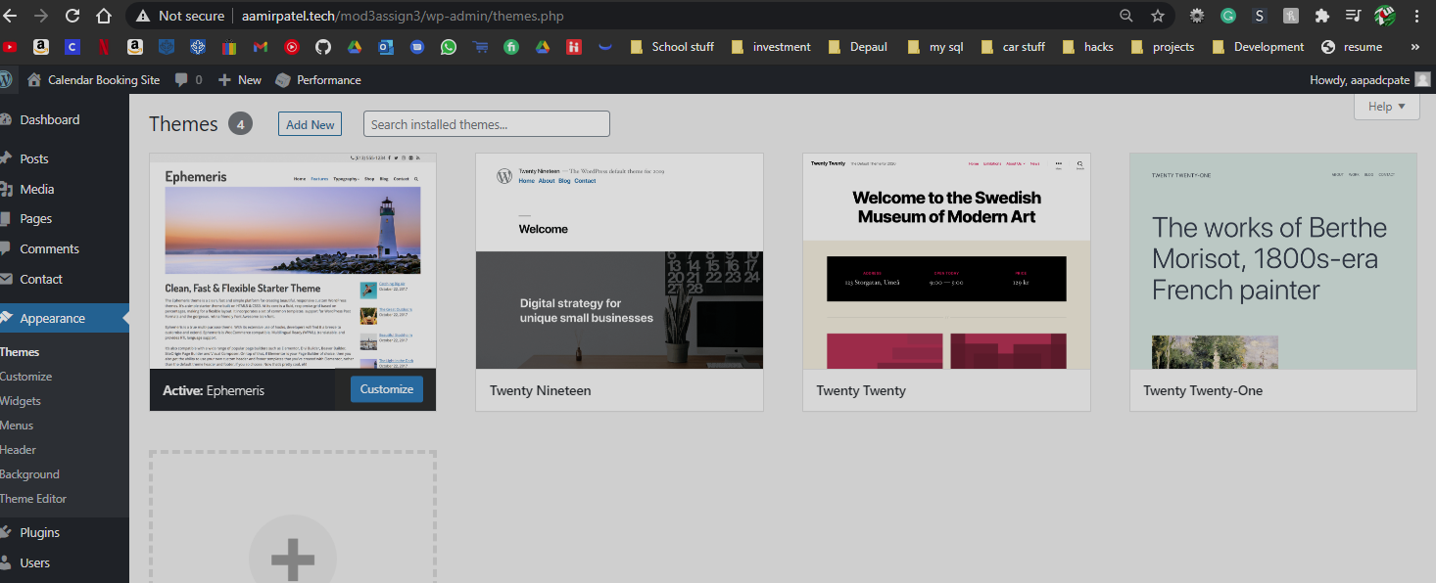]**
2. SCREEN CAPTURE of the backend WordPress **Media** Page **[Dashboard > Media]** showing the site images   
   **[C02]**  
    **[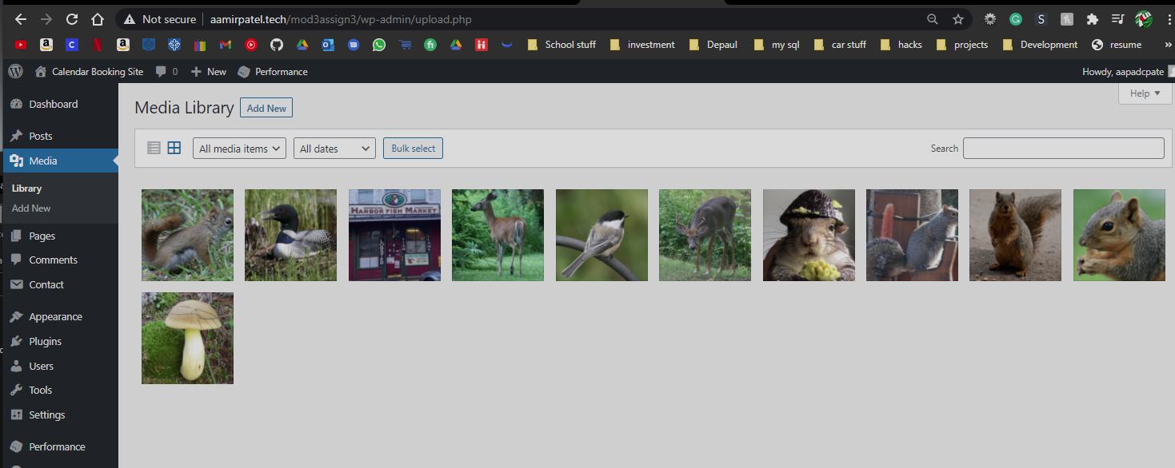]**
3. SCREEN CAPTURE of the backend WordPress **Posts** Page **[Dashboard > Posts]** showing the 2 Posts, categories and Tags  
   **[C03]**  
    **[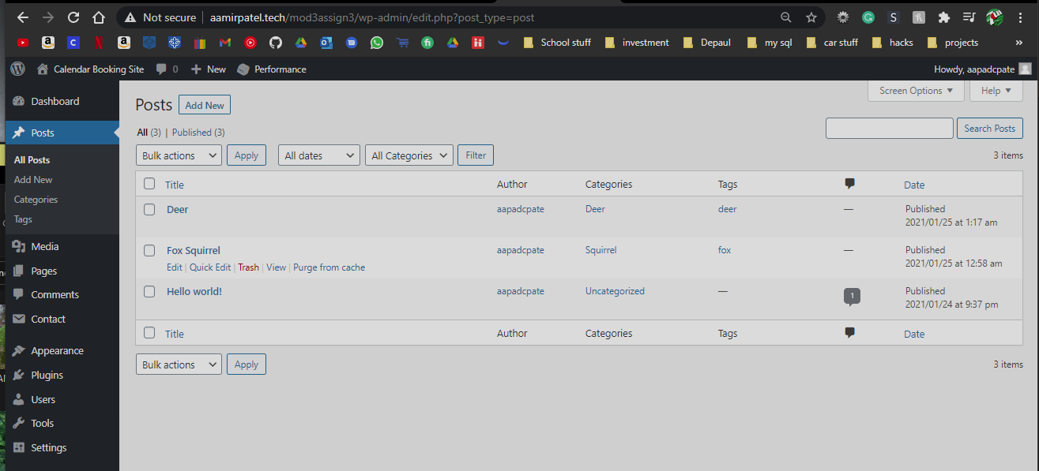]**
4. SCREEN CAPTURE of the backend WordPress **Pages** Page **[Dashboard > Pages]** showing the Pages  
   **[C04]**  
    **[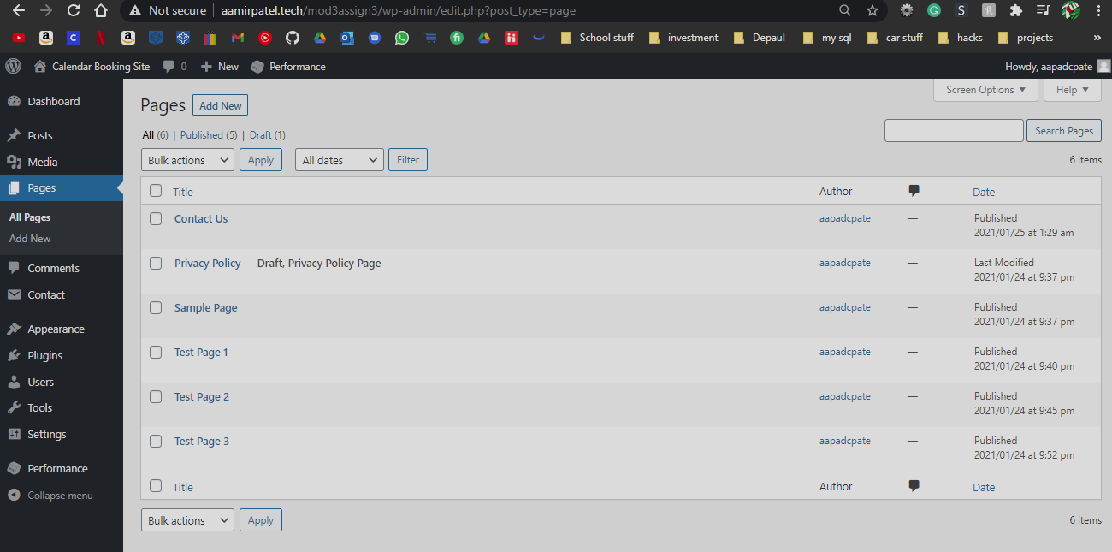]**
5. SCREEN CAPTURE of the backend WordPress **Plugins** Page **[Dashboard > Plugins ]** showing the Plugins you installed   
   **[C05]**  
    **[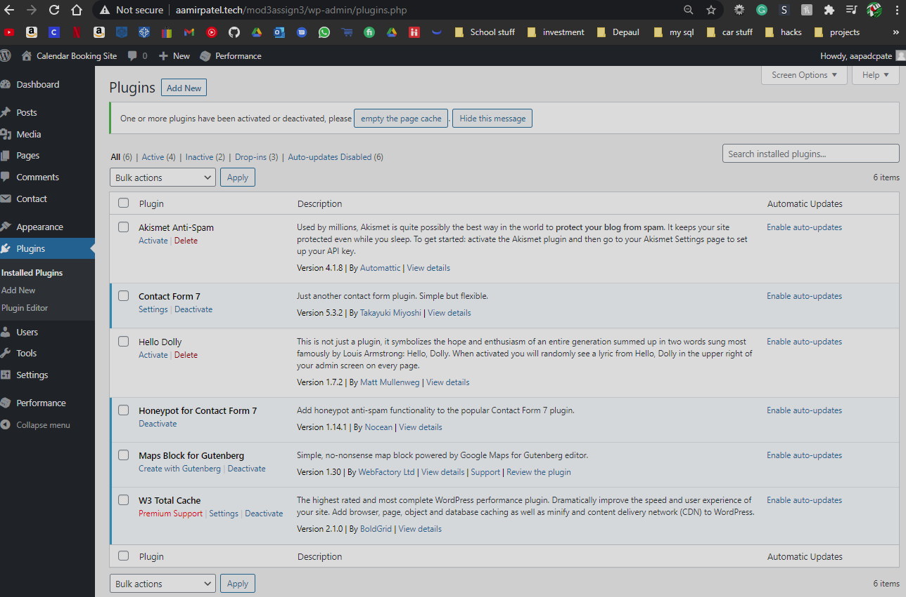]**
6. SCREEN CAPTURE of the backend WordPress **Contact Us Form**    
   **[Dashboard > Contact]** then select Edit on the Contact Us Form  
   This will display the Form fields including the 2 honeypot fields  
   **[C06]**  
    **[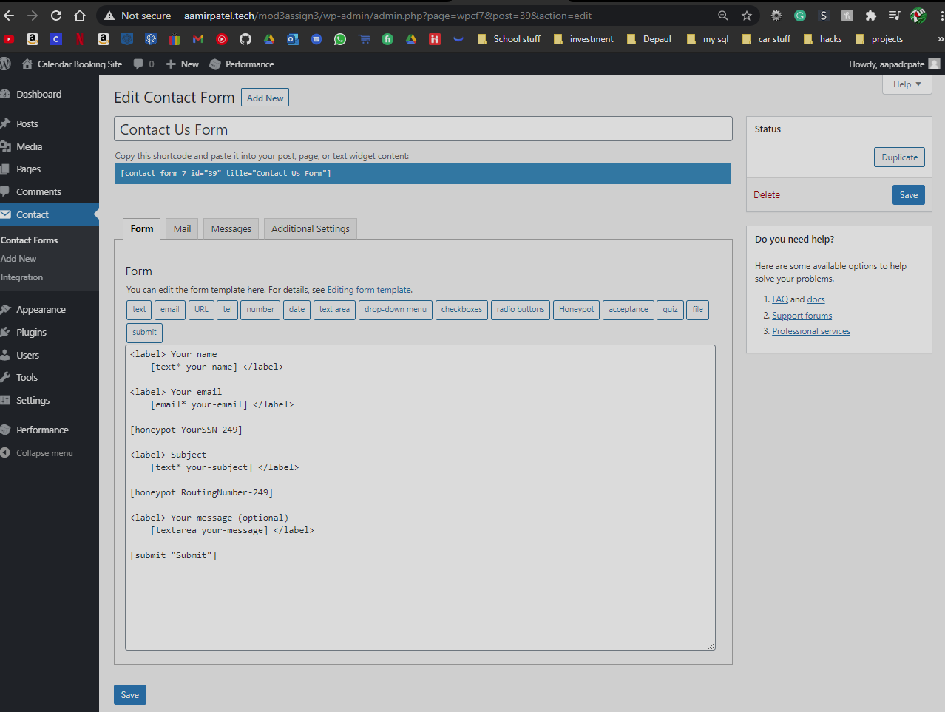]**
7. SCREEN CAPTURE(s) of the client facing FRONT-END showing Page content   
   **[C07]**  
    **[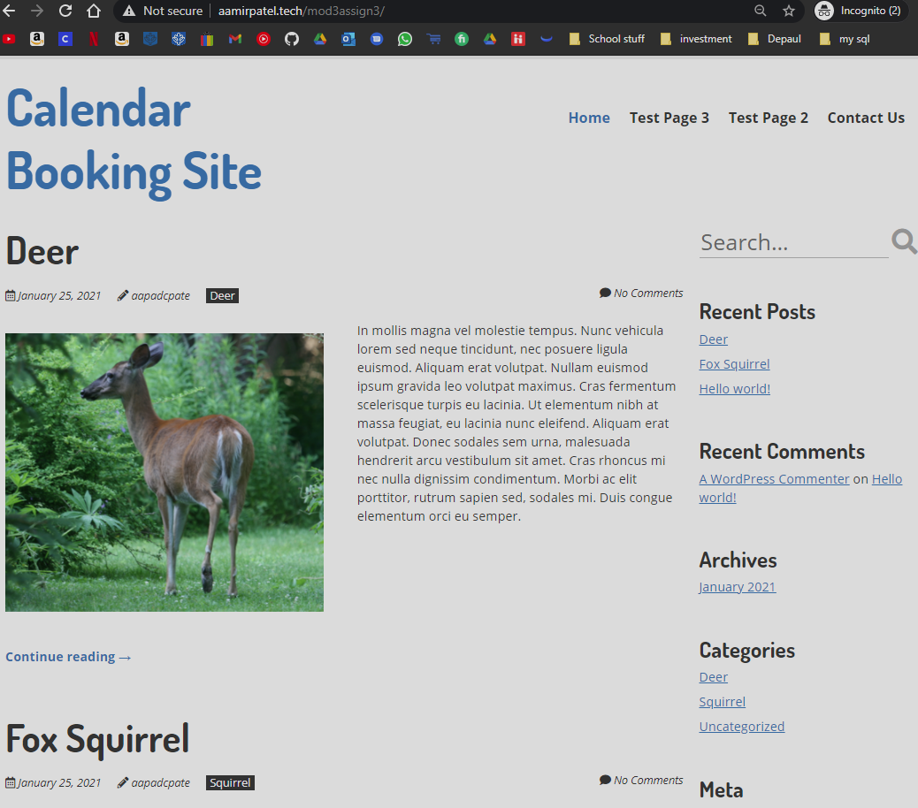]**
8. SCREEN CAPTURE(s) of the client facing FRONT-END showing Post content   
   **[C08]**  
    **[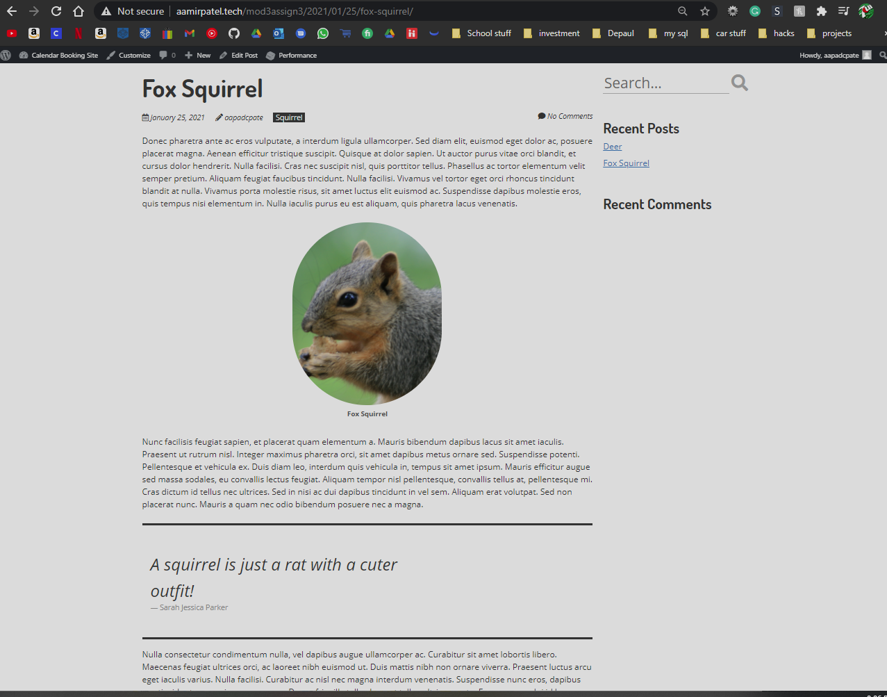]**
9. SCREEN CAPTURE of the client facing FRONT-END showing your Contact Us form   
   **[C09]**  
    **[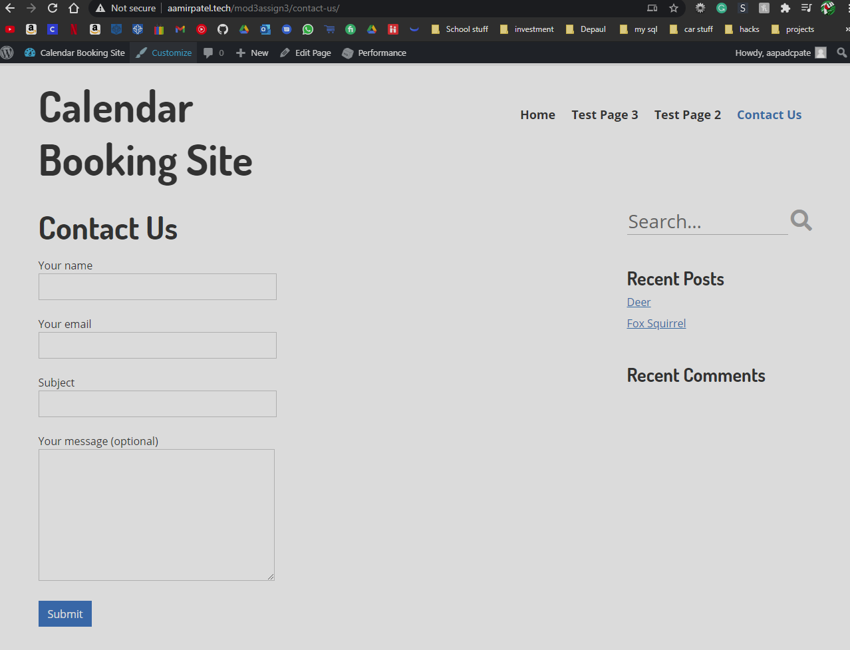]**
10. List the names of the 2 Honey Post Fields you added to the Contact Us form   
    **[C10]**  
     **[**

**- YourSSN**

- RoutingNumber

**]**

**Go back to the instructions and begin work on part D.**

**Part D -** Shared Web Host – Demonstrate CMS Best Practices

1. List the plugins you selected for feature analysis and review**[D01]**  
   **[**

* **Appointment Hour Booking – WordPress Booking Plugin. By CodePeople**
* **Amelia – Events & Appointments Booking Calendar. By TMS**
* **WordPress Online Booking and Scheduling Plugin – Bookly. By Bookly**

**]**

1. Take a screen capture of your feature analysis report and paste it here**[D02]**  
   **[**

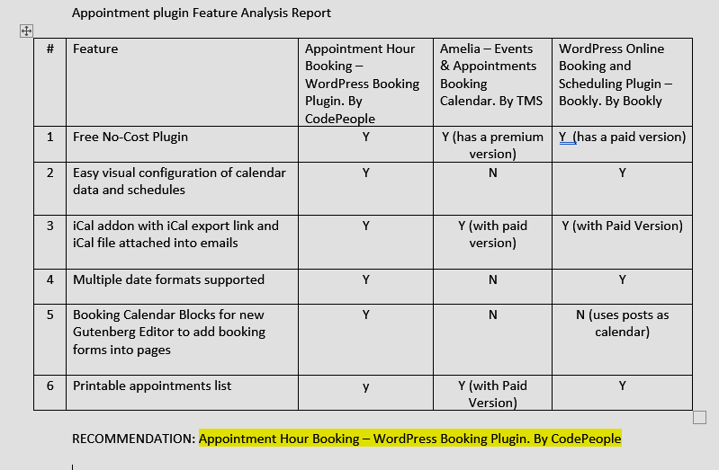

**]**

1. Record the name of the plugin you selected based best practices**[D03]**  
   **[**

**Appointment Hour Booking – WordPress Booking Plugin. By CodePeople**

**]**

1. Write a few sentences that describe the 4 best practices you used to select the plugin**[D04]**  
   **[**

* Made sure it was compatible with our version of WordPress.
* Made sure it was consistently updated
* Made sure reviews were positive and went through multiple reviews to make sure they were not bot generated reviews.
* Made sure there was a sufficient number of active installs for the plugin.
* Also made sure it was the right plugin for our use case scenario.

**]**

1. Backend SCREEN CAPTURE of the **Plugins** Page **[Dashboard > Plugins]** showing your Plugin you selected **[D05]  
   [**

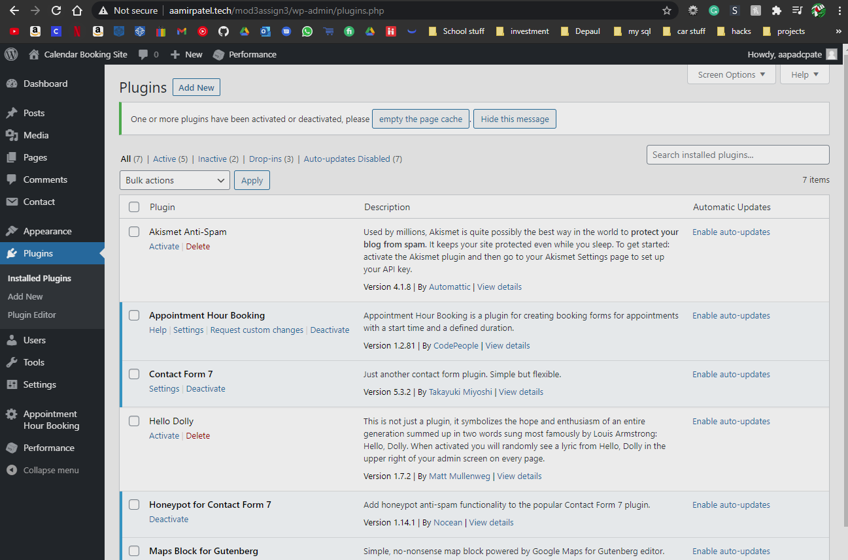

**]**

1. Front-end SCREEN CAPTURES of the implemented **Plugins** Pages**[D06]**   
   **[**

Appointment form 1: - (Dedicated Page)

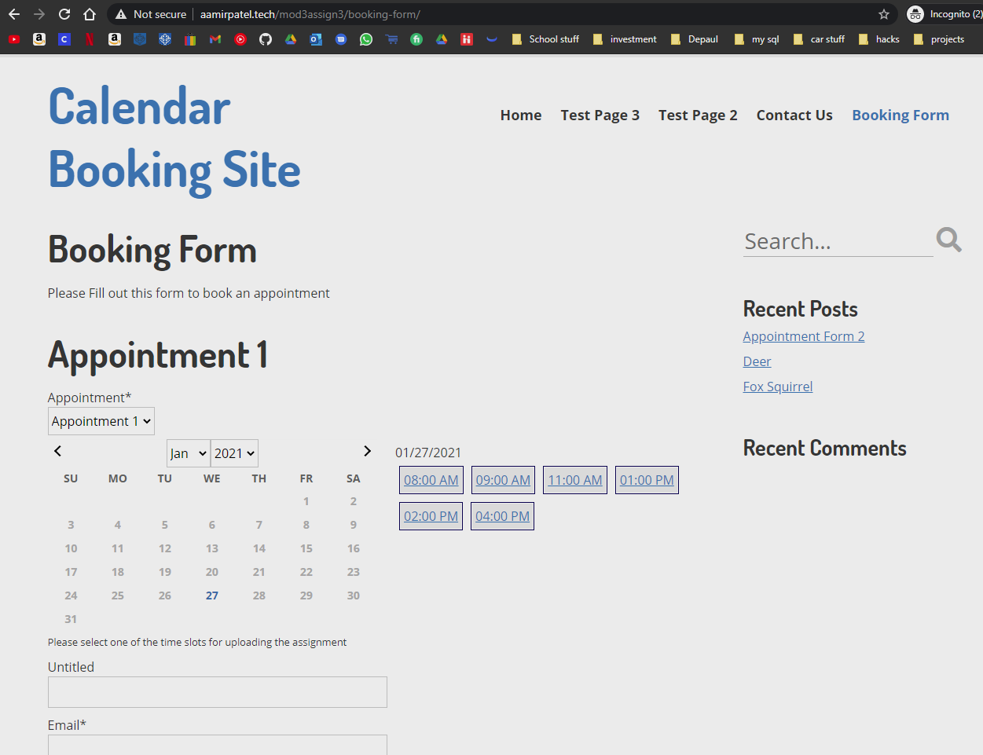

Appointment form 2: - (Post)

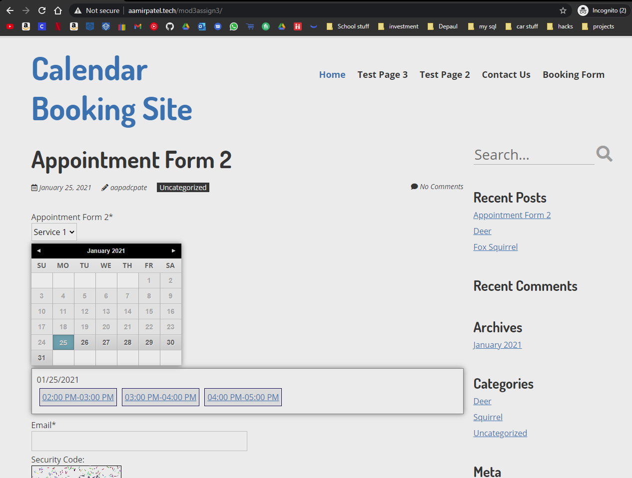

**]**

**Go back to the instructions and begin work on part E.**

**Part E - Testing PHP Programs using PHP Emulation Websites:**

* Online PHP test sites:
  + <http://phptester.net>
  + <http://www.writephponline.com/>
  + <http://sandbox.onlinephpfunctions.com/>
  + <https://wtools.io/php-sandbox>
* How you test your script depends on which test site you use.
* **Each PHP emulation test site works slightly different**.
* Please read the site instructions before testing your PHP code.

For more help on debugging and troubleshooting PHP errors, please refer to the Module 03 Presentation:  
  
M03 -09- PHP Troubleshooting Coding Errors

1. Demonstrate that you can create a PHP index array of 5 items and iterate through it using a   
   for statement (not a foreach). Write and test your PHP code using a web PHP emulator (tester) and take a screen capture of the working code and output window.   
   Please write your own PHP code.  
   Do not copy and paste provided PHP example code.

|  |
| --- |
| ANSWER: [E01] |
|  |

1. Demonstrate that you can create a PHP index array of 5 items and iterate through it using a foreach statement. Write and test your PHP code using a web PHP emulator (tester) and take a screen capture of the working code and output window.   
   Please write your own PHP code.   
   Do not copy and paste provided PHP example code.

|  |
| --- |
| ANSWER: [E02] |
|  |

1. Demonstrate that you can create a PHP associative array of 7 items and iterate through it using a foreach statement. Write and test your PHP code using a web PHP emulator (tester) and take a screen capture of the working code and output window.   
   Please write your own PHP code.   
   Do not copy and paste provided PHP example code.

|  |
| --- |
| ANSWER: [E03] |
|  |

1. Demonstrate that you can create a PHP program that uses control statements.  
    Write and test your PHP code that contains an if and an if else control statements and use a web PHP emulator (tester) and test, debug, fix and eventually take a screen capture of the working code and output window.

|  |
| --- |
| ANSWER: [E04] |
|  |

1. Demonstrate that you can create a PHP program that uses comparison statements.  
    Write and test your PHP code that contains an “==”, “===”, “<” , “>”, and the spaceship “<=>” operator. Use a web PHP emulator (tester) and test, debug, fix and eventually take a screen capture of the working code and output window.

|  |
| --- |
| ANSWER: [E05] |
|  |

**Go back to the instructions and begin work on part F.**

**Part F – Module CMS Questions:**

1. Write a few sentences about the WordPress Gutenberg editor, what it is and what are the benefits to using it over the Classic editor? This question may involve reviewing the assigned reading material. [F01]

|  |
| --- |
| The Gutenberg editor is the latest WordPress editor, it divides everything on your page into blocks, so you can easily arrange and mange them. This editor also gives you a active visual representation on what your webpage is going to look like, and it does not require any coding experience. So changing the locations for everything is very simple and so is adding new items since everything is packed into a blocks. |

2. List and describe the two content types that come installed with WordPress. [F02]

|  |
| --- |
| Page – A page is one of the contents that comes pre-installed with WordPress. Pages are exactly what they sound like, they are a page in your book (website). They help you organize contents and divide them into sections.  Post – A post is a small section of your webpage that has news or informational updates about a certain topic. This is what creates the blog aspect of the webpage. |

3. List and describe 3 similarities and differences between content types Pages and Posts. [F03]

|  |
| --- |
| Similarities: -   * There is no limits on creating pages and posts. * There is also no limit on the number of words you can have on a page or a post. * Both posts and pages can be modified with help of a theme.   Differences: -   * The primary difference between pages and posts is that posts have a publish date displayed on the page, while the page does not have a publish date. * Posts can be categorized with tags and categories, but pages cannot. * Posts have custom formats which all posts follow, but pages rarely have a template. * Can not change order of pages, but you can change order of posts |

4. Write a few sentences about WordPress Categories and Tags such as what content type they are applied to, how are they implemented, and their purpose on WordPress content. [F04]

|  |
| --- |
| Categories and tags are used to organize posts and divide them into specific parts. For example, if you want to organize your posts into vegetables and fruits you use category, and inside the vegetables category you want to divide them into different types of veggies, you use tags. In other words, categories are used as a broad grouping of the posts, and tags are meant to describe specific details of the post. |

5. List and describe 4 basic best practices you should follow when selecting a WordPress plugin, after determining that the plugin has the required features. [F05]

|  |
| --- |
| * Making sure it is compatible for our version of WordPress. This ensures you don’t get any glitches because the plugin was not updated. * Making sure it was updated frequently. This Is more important, because if the plugin does not get frequently that means that the developers does not support it, and if you get stuck with it you shouldn’t expect the developers to help you with it. * The reviews needs to be good, reviews tells a lot about a plugin, if the plugin does not have good reviews that means that the community is not happy with the plugin. * Making sure the amount of active users is high, this shows us how many people have the plugin active on their webpages, and add that to the reviews to determine the quality of the plugin. |

**Go back to the instructions and begin work on part G.**

**Part G – Assignment Wrap up:**

1. **Did you have any problem or issues completing this assignment?  
   This is not an optional question.  
   [No] [G01]  
     
   If you answered yes to this question, please elaborate and be specific.  
   If you had trouble with a specific question, please identify it by number and explain what you did not understand or had problems with.  
   I can only improve this assignment with your help.**
2. **[**List problems here**]   
   [G02]   
   *Only if you answered Yes to [G01] above or if you left one or more parts empty in the template.**

Submit this completed template to the correct D2L assignment dropbox.If you prefer not to navigate by hand to the D2L dropbox, take advantage of the dropbox link in the D2L this module’s section. This link will take you to the correct assignment dropbox location.